How to make a raincloud in a jar!
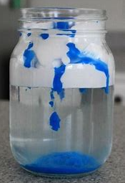
Equipment
Shaving foam
Small bowl
Pipette or syringe (from a calpol bottle)
Blue food colouring
Water
A large, clean jar

Method
- Fill the jar with water, leaving a 2 inch at the top.
- Add the shaving cream to the top of the water, so it goes right to the top.
- Next add one cup of water to the small bowl and add 3 drops of food colouring.
- Mix the food colouring and water together.
- Use the pipette to add drops of the water mixture to the top of the shaving foam cloud.
- Continue adding the water mixture until you notice the raindrops begin to drop through the bottom of the cloud.

What is happening?
The shaving foam, stays on top of the water and acts like a cloud. As the water droplets are added to the cloud, the shaving foam is no longer able to contain them and they fall through like raindrops.
More about clouds
Did you know that there are different types of cloud depending on the weather?
See if you can find examples of these ones and draw them in the boxes.
Stratus | Cirrus
Cirrocumulus | Cumulonimbus
Altocumulus | Nimbostratus

Find out 5 fun facts about clouds! They’re amazing!

