Make your own fossils
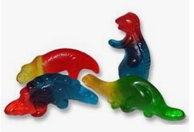
Equipment
2 slices of white bread, gummy sweets, heavy books, kitchen roll

Method
- Put a piece of bread onto a piece of kitchen roll.

- Put a selection of gummy sweets on the bread. Spread the sweets out.

- Next put the second slice of bread on top.

- Add another piece of kitchen towel and stack a few heavy books on top.

- Leave the sandwich for 2 days, then carefully open it up and look at the fossils.
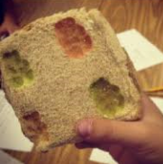
What is happening?
The gummy animal is like an ocean animal that has died and settled on the ocean floor. The bread is like layers of sediment, above and below it. The books add the pressure of all the sediments that built up over millions of years.
After 2 days, you can start to see some of the changes that happened when a real fossil forms:
- The layers of sediment begin to ‘glue’ together.
- The fossil leaves an impression in the sediments.
- Parts of the animal begin to seep out into the rock.
- It may disappear altogether, and be replaced by minerals from the rock, to make a hard fossil.
- Or the goo left behind may eventually become oil and natural gas.
*Key vocabulary is written in red.

Find out more about fossils…
What do we call scientists who study fossils?

Where does the word fossil come from?

The first dinosaur fossils were named in 1824. Which dinosaur were they from and which parts of its body were they?

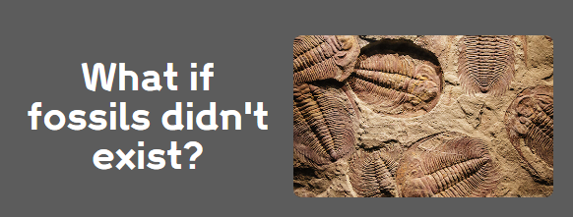
Write a short paragraph to answer this question.

