Fun with shadows
Equipment
Card, lolly stick or straw, torch, pens, sticky tape
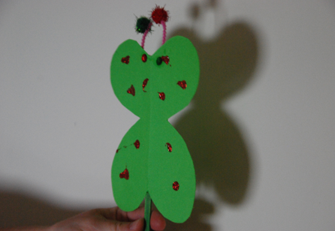
Method
- Draw some shapes onto some cardboard, and cut them out.

- Attach the shape to a lolly stick or straw.

- Decorate if you wish. The example in the picture shows a butterfly which has been decorated with glitter and uses pipe cleaners and little balls for the antennae.

- In a dark room hold the shadow puppet against a wall and shine the torch or a light at them.

- You should see the shadow of the puppet on the wall.

- Try moving the puppet closer and further away to the wall – what do you notice about the shape of the shadow.
What is happening?
The puppet is blocking the light from the torch, which forms a shadow on the wall. In real life the sun casts shadows, as objects block its light rays. Shadows will alter in size and shape depending on the sun’s position in the sky. As the sun rises and sets, shadows will be longer. When the sun is at its highest point in the sky, shadows will become shorter. *Key vocabulary is written in red.
What next?
Try building people or animals with pipe cleaners. Can you make shadow twice as tall as another?
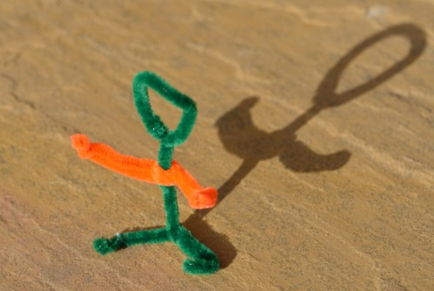
Can you make some 3D shapes and draw their shadows?
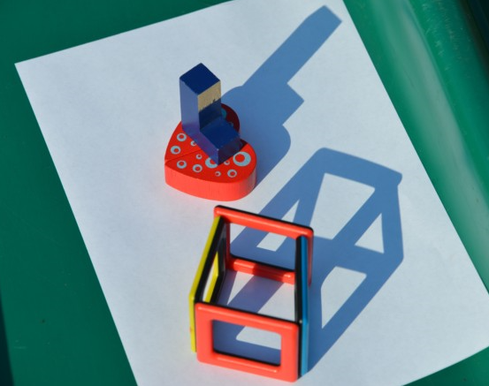
Try drawing round some favourite toys!
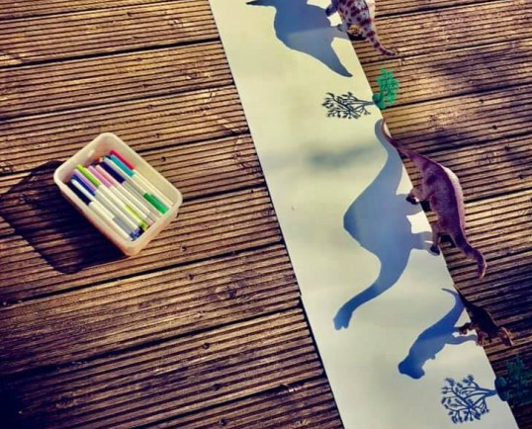
Have a go at these activities at different times of the day – how do their shadows change?

