How to make fizzing bath bombs!
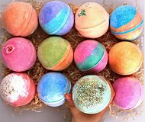
Create an ‘explosion’ of bubbles and scent in your bath!
Equipment
275g of bicarbonate of soda
85g cream of tartar
A bowl and spoon
1tbsp vegetable oil
1 tsp of vanilla, almond or rose essence
Cupcake cases

Method
- Mix the dry ingredients really well.
- Add the flavouring, this isn’t for eating, it just smells nice!
- Mix really well.
- Gradually mix the oil until the mixture clumps together. Press the mixture firmly and gently make into a ball. You may want to make 1 large one, or several small ones.
- Put into the cupcake cases and leave to dry for a few hours.
- After a few hours, they are ready to use. Pop one in to your bath, sit back and watch the bath bomb explode!
Use the bath bomb within 2 weeks otherwise it will lose its fizz.

What’s happening?
The bicarbonate of soda is an alkali and the cream of tartar is acidic. The water in the bath allows these two ingredients to react together, releasing bubbles of carbon dioxide gas.

Now try this…
Your bath bomb created carbon dioxide, a type of gas. Take a look at these 3 ‘gassy’ images and work out which is the odd one out!


Baths over the years
Here’s a selection of baths throughout the ages. Whilst they all look different they also have some features the same. Can you name 3 similairites and 3 differences?

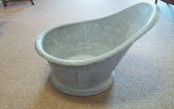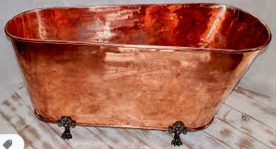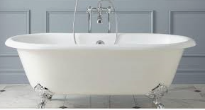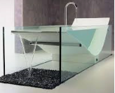
Similarities | Differences

Why did the burglar steal a bath? He wanted to make a clean getaway!
Gave my pet leopard a bath every day. Now he’s spotless.
Someone has stolen all the soap from my bath. I think it was my robber duck!

