
Oxford Diocesan Bucks Schools Trust (ODBST)

“ODBST - Empowering Lives, Flourishing Together”
Living ‘life in all its fullness’ (John 10:10)

ODBST – Empowering Lives, Flourishing Together
Living “life in all its fullness” – John 10:10

Our vision becomes a reality through living our values.

Our ODBST Values in action


Our purpose is clear: we want every young person to achieve all that they possibly can and, in doing so, to ensure they and their families experience the highest quality of education and care.

- Inclusivity is seen when our differences become our strength and lead to shared achievement.
- Community is seen when young people and adults are learning, loving, achieving, and flourishing together.
- Service is seen when young pupils and adults seek the common good in all that they do.
- Empowerment is seen when pupils can say, “I am special because… and I am learning to excel at…”

Each of our schools has its own character and serves a unique community, but we are united by a shared vision. We are committed to ensuring that this vision embraces every pupil and adult, regardless of background or belief. This unity fosters a common zest for life and learning, enabling us to deliver a broad, enriched, and exciting curriculum. We are dedicated to helping every young person experience life in all its fullness by empowering them to reach their highest potential. We believe in inclusivity, ensuring everyone feels valued, respected, and part of our larger family. Our strength lies in the collaboration across our schools - working together as one unified body, sharing resources, expertise, and support to ensure that no one is left behind. Our unique school communities thrive on mutual support, shared learning, and the collective goal of making a positive impact. Through our commitment to service, we aim to make a difference not only within our schools but also in the wider world. Together, we create an environment where every young person and adult can flourish, embracing all the opportunities life and learning have to offer.
Our vision for empowering lives and flourishing together is rooted with Jesus' promise of 'life in all its fullness’.

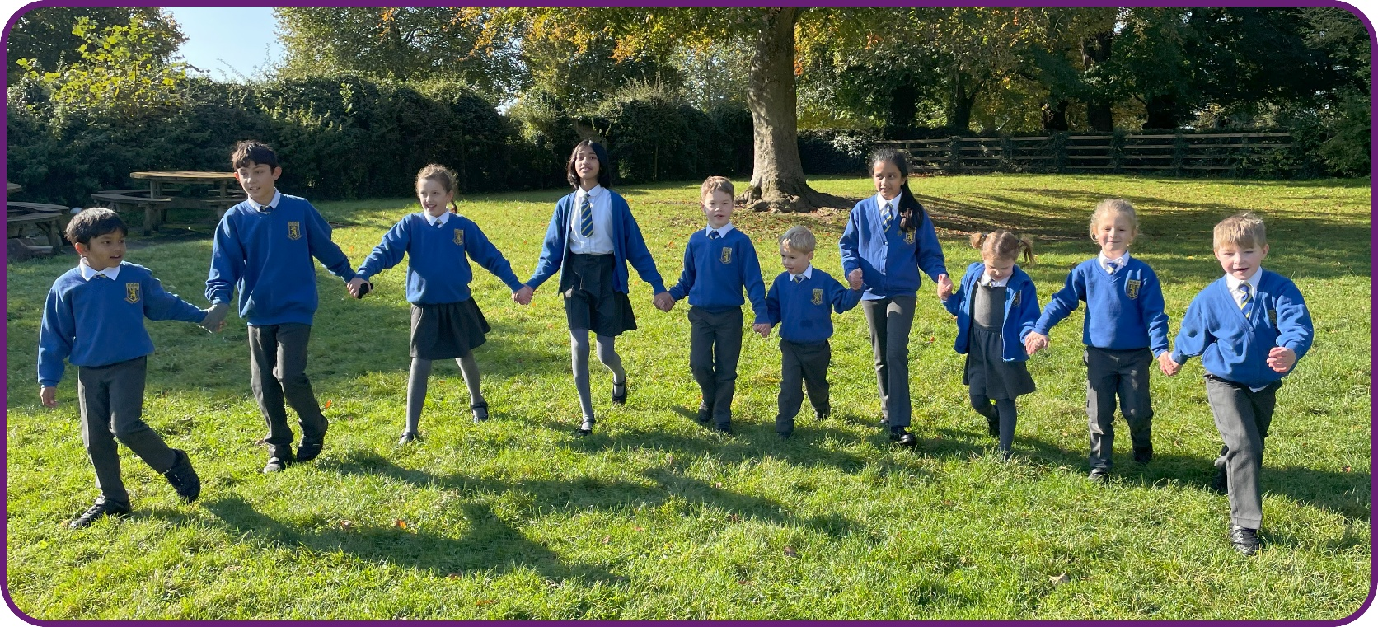

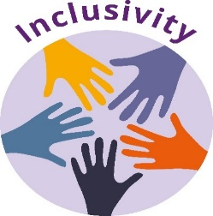

At ODBST this means that everyone is accepted and supported, regardless of faith or culture. We will strive for everyone to be given every opportunity to reach their potential. We believe everyone is unique and everyone matters.
Many pupils and staff in our schools will come from diverse home backgrounds and our pupils will be at different stages of their own academic and spiritual journey during their time in school. All pupils will receive support, guidance, and challenge so that they are motivated, ambitious, and courageous individuals who seek to be the best they can be. We embody the experience of an inclusive community, where we share our gifts, where the emphasis is on what we can contribute, rather than on what we might receive and where we give to each according to need.

“Our differences are our strength as a species and as a world community.”

Nelson Mandela

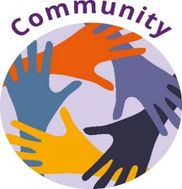

At ODBST we work in unison with all our families. Together we learn, love, achieve and flourish. Within our family of schools, each individual is encouraged to discover and grow their talents to their fullest potential. We believe by encouraging, inspiring, and building each other up we secure the best outcomes for every member of our community.

We believe quality relationships and partnerships are a central element of interdependence: all are needed and valued, and each person is important. We will work together to support each other so that everyone can make a contribution, and everyone feels included. We encourage everyone to have a sense of pride in their community and the wider world.

“The minute we become an integrated whole, we look through the same eyes and we see a whole different world together.”

Azizah Al-Hibri



We encourage everyone to look after themselves and others around them. We encourage pupils in our schools to seek the common good in all that they do through acts of kindness. The ODBST believes that our gifts and talents are to be used in ways that will improve the lives of themselves and others.

We help children to develop skills that will allow them to participate fully and contribute positively to the social and cultural life of modern Britain, maximizing opportunities for our pupils to serve their school and local community. We create a culture where serving one another and the wider community is celebrated and seen as an important mark of character development. We regularly invite visitors to our schools who are making a difference to society through their service and courageous advocacy, to inform and inspire us and to present positive role models with ethical and moral integrity for us to follow.

“The best way to find yourself is to lose yourself in the service of others.”

Mahatma Gandhi



At the ODBST we will encourage everyone to trust in their own capabilities and to recognise their potential. We want to challenge ourselves to be the best we can be – even when this becomes hard.

We will do this by leading by example, supporting, and guiding one another, celebrating accomplishments, providing opportunities for all, developing confidence, resilience, and perseverance in both our children and our adults. We will encourage curiosity with a mindset of continuous improvement and personal growth. We want our pupils to be able to say, ‘I am special because and I am learning to excel at….’

"There is no gate, no lock, no bolt that you can set upon the freedom of my mind"

Virginia Woolf

